Talented Young Scientist Program

**I. Background**

Talented Young Scientist Program (TYSP) is Chinese government’s international mobility scheme aimed at cultivating future leading science and technology personalities together with other developing countries.

TYSP promotes cross border exchanges of excellent young scientists, scholars and researchers. TYSP also enhances cooperation among research institutes, academics and enterprises.

TYSP offers job opportunities and sponsorship (¥12,500/month) for talented young scientist from developing countries to work in China on full time basis for 6/12 months, together with China’s team.

**Big Events:**

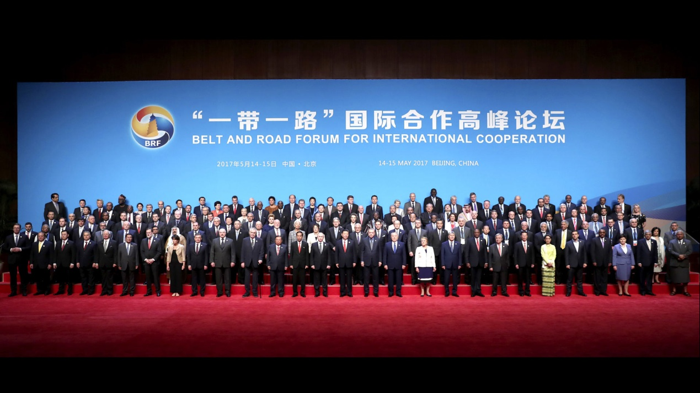

5.14-15. 2017 Belt and Road Forum for International Cooperation

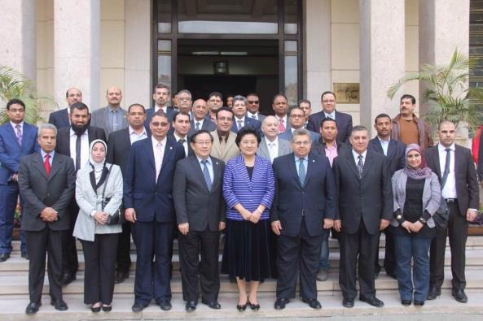

2016.3 Prime Minister Liu Yandong visiting Egypt

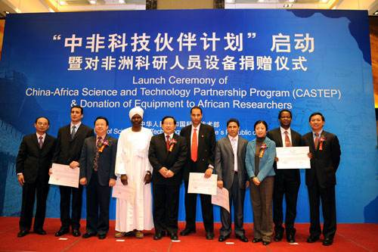

11.24.2009 China-Africa Science and Technology Partnership Program (CASTEP)

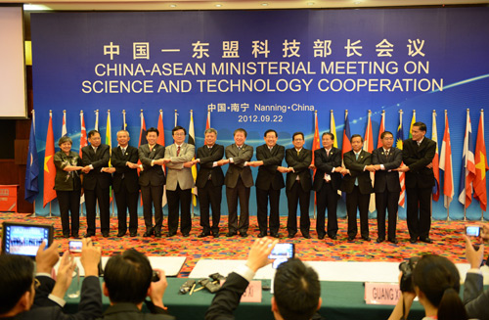

9.22.2012 China-Asean Ministerial Meeting on Science and Technology Cooperation

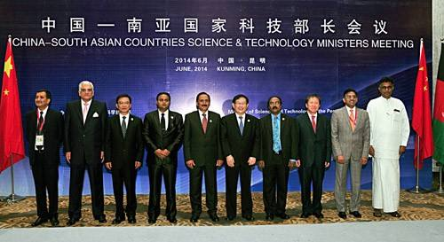

6.6.2014 China-South Asian Countries Science & Technology Ministers Meeting

**II. Stake Holders**

1. Guidance

Department of International Cooperation, Ministry of Science and Technology

(http://www.most.gov.cn)

1. Operation

China Science and Technology Exchange Center

(http://www.cstec.org.cn/zh/index.aspx)

1. Host Institute

Science research institute, or an institution of tertiary education or an enterprise that has been legally set up in China

1. Referee

Government institutions for Science and Technology, Diplomatic representatives, etc.

**III. Eligibility of Position**

1. Non-secret post
2. ~~I~~ Non-degree education postScience technology research or policy research posts
3. Multi culture/nationality team

**IV．Qualifications for Host Institutes**

1. Legal entities in China: university, research institute or enterprise, etc
2. Good working conditions
3. Assisting the international expert in processing his /her necessary documents such as Entry Visa, Foreign Expert Certificate and Alien's Residence Permit.
4. Providing financial support before sponsorship allocated

**V. Eligibility of Applicants**

1. Full-time job on science technology research or policy research in homecountry
2. Five years of research experience or with a doctoral degree
3. Under or at the age of 45
4. Fluency in English or Chinese mandarin
5. Willing to work in China on a full-time basis
6. Undertake to comply with laws, regulations and other related rules in China.

**VI. What Can Applicants Obtain?**

1. Financial support:PretaxRMB ¥ 12,500/month for accommodation, insurance and living expenditure
2. Job opportunities: 6/12 monthsWorking with the best research team in the world and fulfill research ideal
3. Certification of TYSP: Proof of high level research experience

**VII. Application procedure**

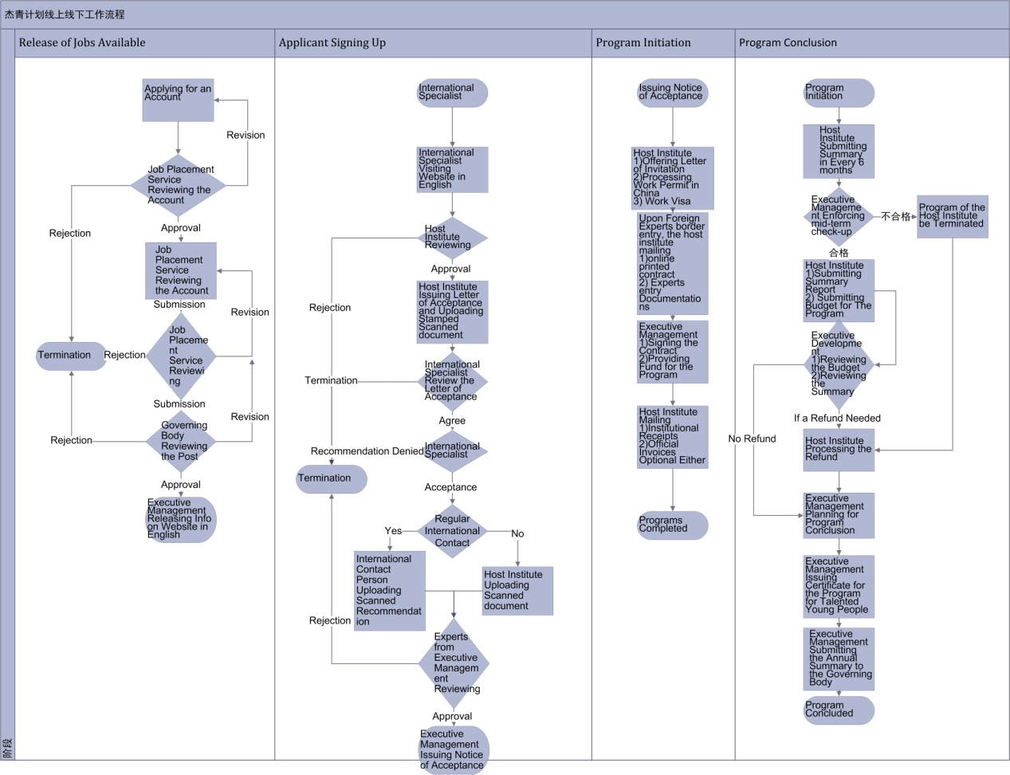

**VIII. Time Lines**

Applications are accepted all the year round with the vetting process scheduled on a quarterly basis in January, April, July and October.

**XIV References**

**1. TYSP Team**

Website: [http://tysp.cstec.org.cn](https://tysp.cstec.org.cn)

E-mail: [tysp@cstec.org.cn](mailto:tysp@cstec.org.cn)

Phone: +86-10-68574085

Address: 54 Sanlihe Road, Beijing 100045, China

**2. Useful Links**

Ministry of Science and Technology of China

<http://www.most.gov.cn>

Department of International Cooperation, MOST

<http://www.cistc.gov.cn>

China Science and Technology Exchange Center

<http://www.cstec.org.cn>

Ministry of Foreign Affairs of China

<http://www.fmprc.gov.cn/web/>

State Administration of Foreign Experts Affairs of China

<http://www.safea.gov.cn>

Bureau of Exit and Entry Administration of the Ministry of Public Security

http://www.mps.gov.cn/n2254996/index.html

China Academy of Science

http://www.cas.cn/

**3. Abbreviations**

AF Application Form

AFOP Application Form of Position

CSTEC China Science and Technology Exchange Center

HI Host Institute

LOC Letter of Consent

RF Recommendation Form

TYSP Talented Young Scientist Program

**photos**：

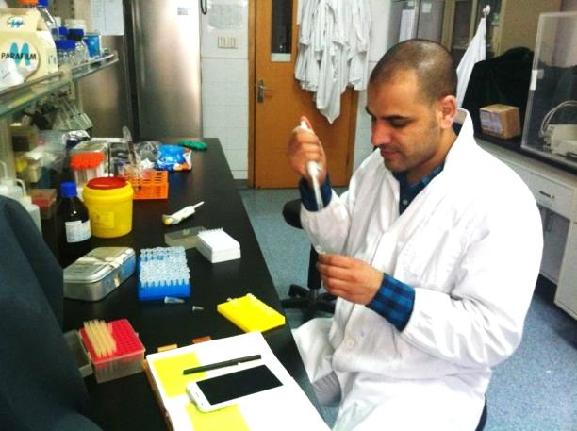

Dr. Mohamed Habib in the lab

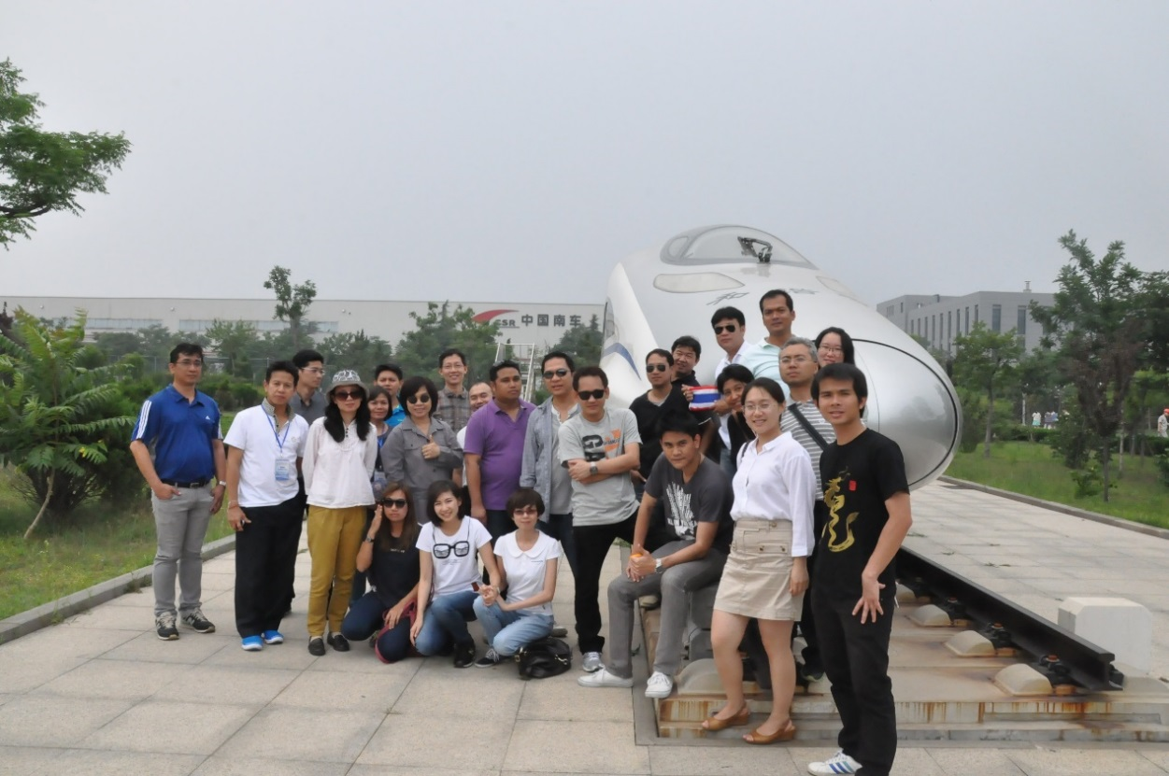

Dr. Chayakorn（3rd right）and Dr. Chokchai（4th behind right）with the high railway system

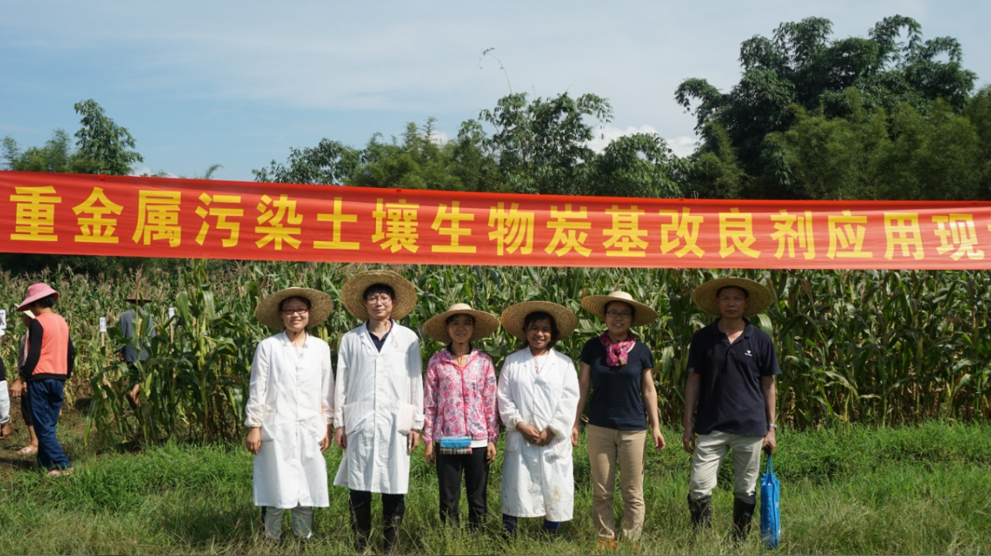Dr. Nyo Nyo Mar（3rd right）working in the recovered field

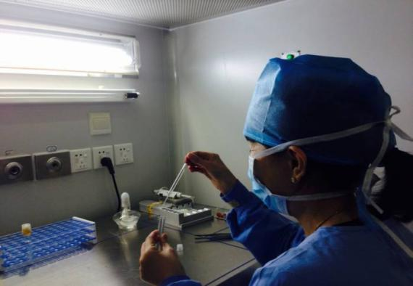

**精子优化**

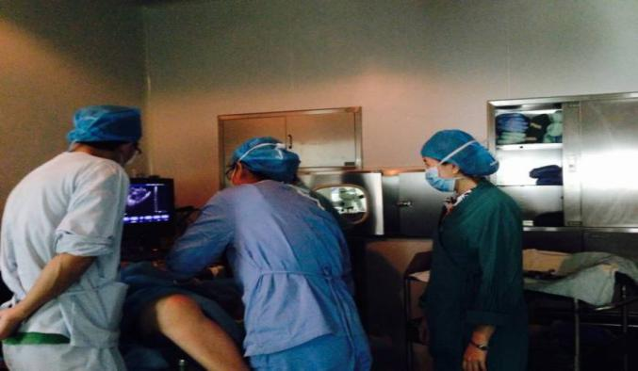

**取卵手术**

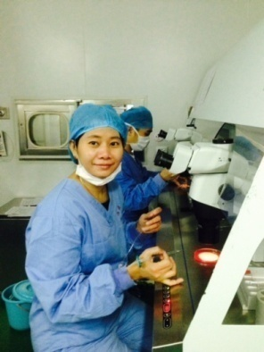

**IVF**

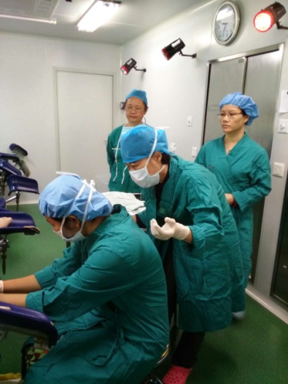

**胚胎移植**

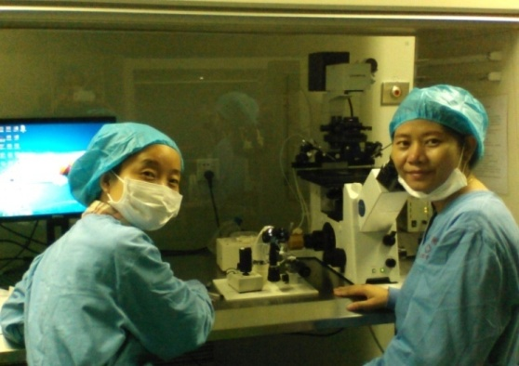

**观察胚胎**

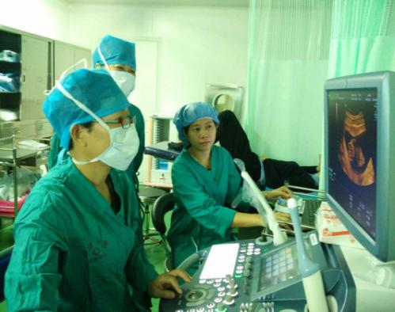

**胎儿超声**

**实验操作**

Dr. Hnin Thinda Tun and Dr. Mee Mee Thet work in China